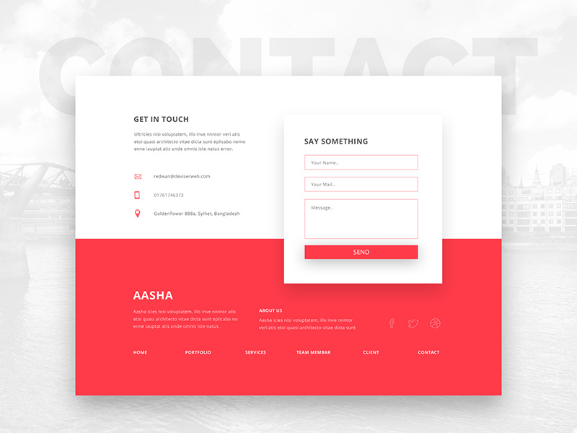

**Exploring adventures beyond**

**any scope.**

A unique dive into authors imaginations, creativity, experiences and thoughts.

Loren ipsum lorem ipsum  lorem ipsum  lorem ipsum  lorem ipsum  lorem ipsum  lorem ipsum  lorem ipsum  lorem ipsum .

View Books



Choose a book category:

Book Categories

* Blue: Blue is often associated with intelligence, trustworthiness, and calmness. It is a popular choice for nonfiction books, particularly those dealing with business, self-help, or history.
* Black: Black is a sophisticated and elegant color that can also convey mystery, suspense, or power. It is often used for thrillers, crime novels, or fantasy books.
* White: White is a clean and simple color that can represent purity, innocence, or new beginnings. It is sometimes used for literary fiction, poetry, or self-help books.
* Yellow: Yellow is a cheerful and optimistic color that can represent happiness, creativity, or new beginnings. It is sometimes used for children's books, lighthearted fiction, or self-help books.

BLOG

Reviews

Booklists

GET IN TOUCH

          ************@gmail.comFor more details, contact through:

        +237 6****************

Buea, Cameroon

SUGGESTION

 Your name …..

Your mail …….

Message ……

HOME

BLOGS

MERCH STORE

CONTACTS

ABOUT US

MERCH STORE 

CART (0) 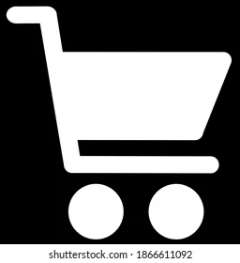

PROFILE 

BOOKERS